JSP – Java Server Pages

A JSP can do everything that a Servlet can do.
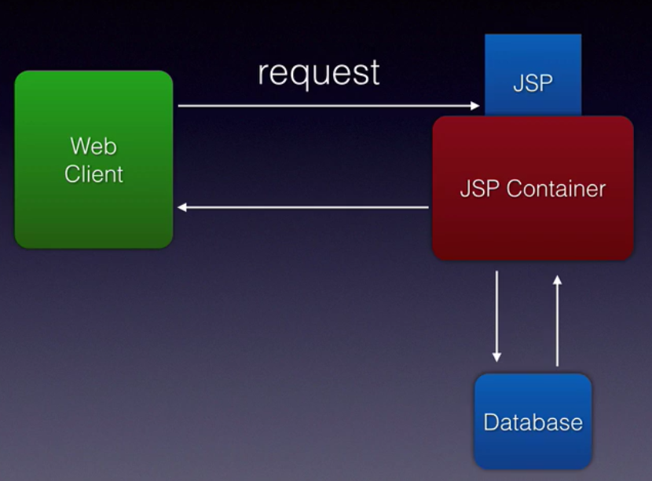

Separation of Java and HTML code and eliminates lot of boiler plate code that we had to write with Servlets.

JSP Elements :

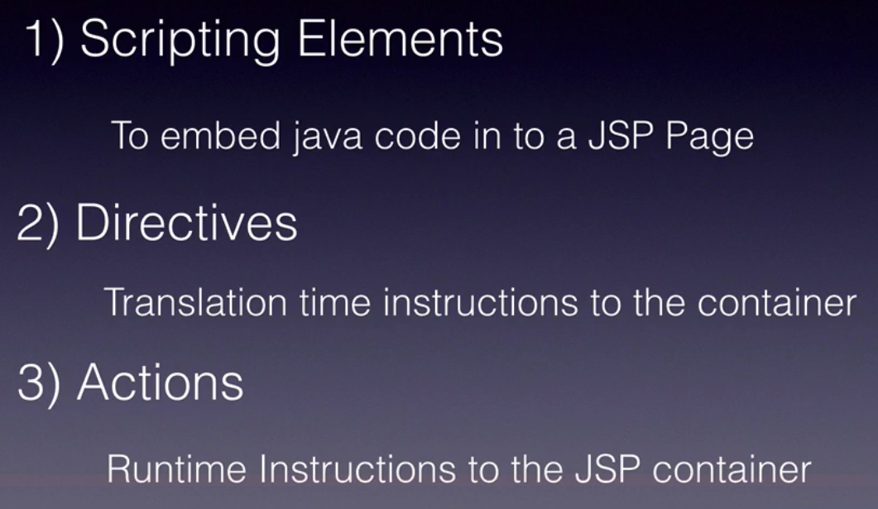

JSP Lifecycle methods and phases :

3 life cycle methods :
- jspInit( )
- _jspService( )
- jspDestroy( )

phases :
- Translation
- Compilation
- Instantiation
- Initialization
- Servicing
- Destruction

Transalation :

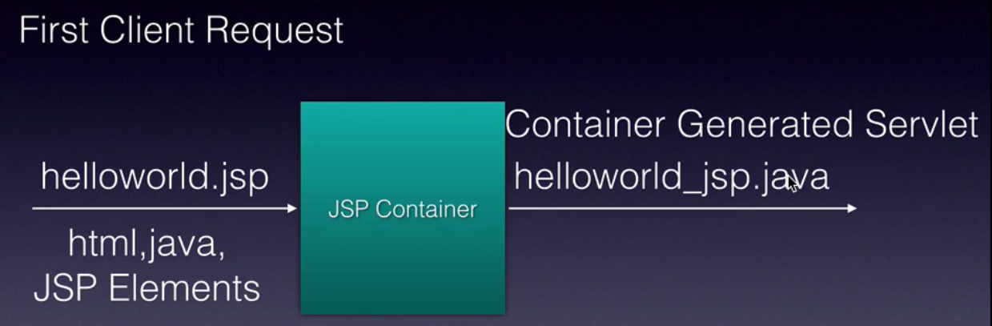

Translation and compilation happens once, unless the JSP code is modified.

Hello.jsp :

JSP pages come under webcontent folder. (project root folder)

<%@ page language="java"
contentType="text/html; charset=ISO-8859-1"
pageEncoding="ISO-8859-1"%>
<!DOCTYPE html PUBLIC "-//W3C//DTD HTML 4.01 Transitional//EN" "http://www.w3.org/TR/html4/loose.dtd">
<html>
<head>
<meta http-equiv="Content-Type" content="text/html; charset=ISO-8859-1">
<title>Hello World</title>
</head>
<body>
<h1>Welcome to JSP World!!</h1>
</body>
</html>

Implicit Objects : 9 objects

There are 9 implicit objects that are available to all JSP pages.

- config - ServletConfig
- request - HttpServletRequest
- response - HttpServletResponse
- session - HttpSession
- application - ServletContext
- page - java.lang.Object
- pageContext - javax.servlet.jsp.PageContext
- exception - java.lang.Throwable
- out - javax.servlet.jsp.JSPWriter

Scripting Elements : allow us to directly embed Java code into JSP page. 3 types.
- Declaration <%! ..... %>
- Expression <%= ..... %>
- Scriptlet

Declaration : <%! .... %>
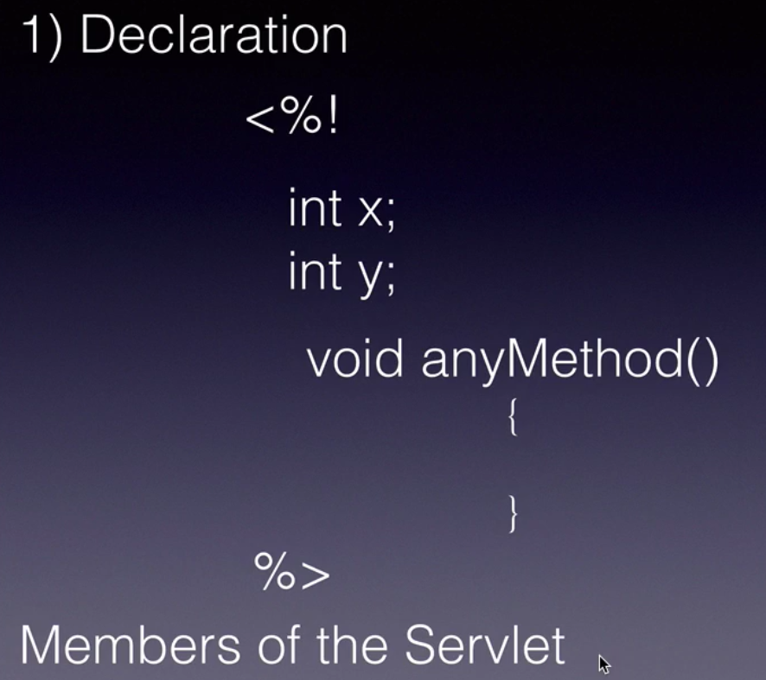

Expression : <%= ..... %>


All this code goes into _jspService method.

Scriptlet : widely used. Write our business logic, java code here.
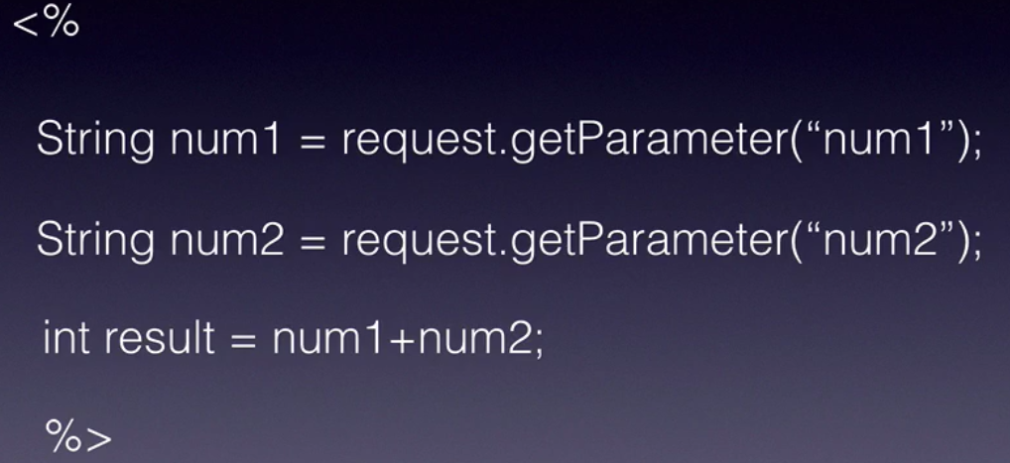

All this code goes into _jspService( ) method.

JSP Directives : https://www.javatpoint.com/jsp-page-directive

During translation time, we want to instruct JSP Container how the resultant servlet should be and what should be in the resultant servlet. Those instructions can be specified using JSP Directives.

The jsp directives are messages that tells the web container how to translate a JSP page into the corresponding servlet.
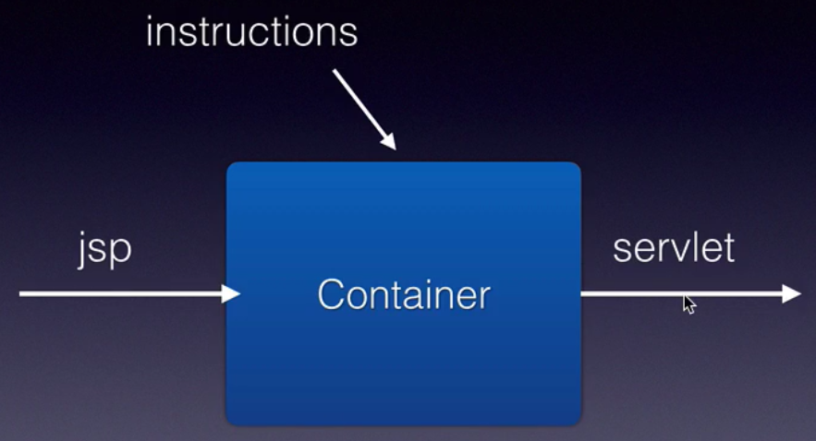

3 types of directives :
- include
- page
- taglib

include :
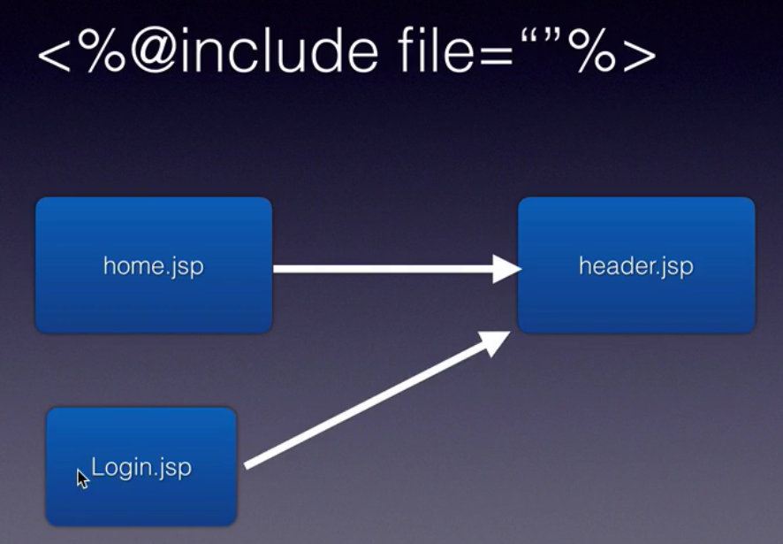

Page :

The page directive defines attributes that apply to an entire JSP page.

Ex:
<%@page import="java.util.Date" %>
Today is: <%= new Date( )%>

taglib :

The JSP taglib directive is used to define a tag library that defines many tags. We use the TLD (Tag Library Descriptor) file to define the tags.

<%@taglib uri="uriofthetaglibrary" prefix="prefixoftaglibrary" %>

Example :

<%@taglib uri="http://www.javatpoint.com/tags" prefix="mytag" %>
<mytag:currentDate/>

JSP Error Handling :

<%@ page language="java" contentType="text/html; charset=ISO-8859-1"
pageEncoding="ISO-8859-1" errorPage="errorHandler.jsp"%>

On the errorHandler.jsp page :

<%@ page language="java" contentType="text/html; charset=ISO-8859-1"
pageEncoding="ISO-8859-1" isErrorPage="true"%>

